os
Lab 2
name: Mohamed Essam Mohamed
id : 3879 Group : 4

Introduction:
- We have decided to improve the train efficiency by automating not just the trains but also the
passengers. From now on, passengers will be
robotsEach robot and each train is controlled
by a thread. You have been hired to writes
ynchronization functions that will guarantee
orderly loading of trains.

Main used function & description :
- When a train arrives in the station and has opened its doors, it invokes the function
- station_load_train(struct station *station, int count) , where
count indicates how many seats are available on the train. The function must not
return until the train is satisfactorily loaded (all passengers are in their seats, and
either the train is full or all waiting passengers have boarded).

- When a passenger robot arrives in a station, it first invokes the function
station_wait_for_train(struct station *station) . This function must
not return until a train is in the station (i.e., a call to station_load_train is in progress)
and there are enough free seats on the train for this passenger to sit down. Once this
function returns, the passenger robot will move the passenger on board the train and
into a seat (you do not need to worry about how this mechanism works).

- Once the passenger is seated, it will call the function station_on_board(structstation *station) to let the train know that it's on board.

Snapshot from program:
header file:
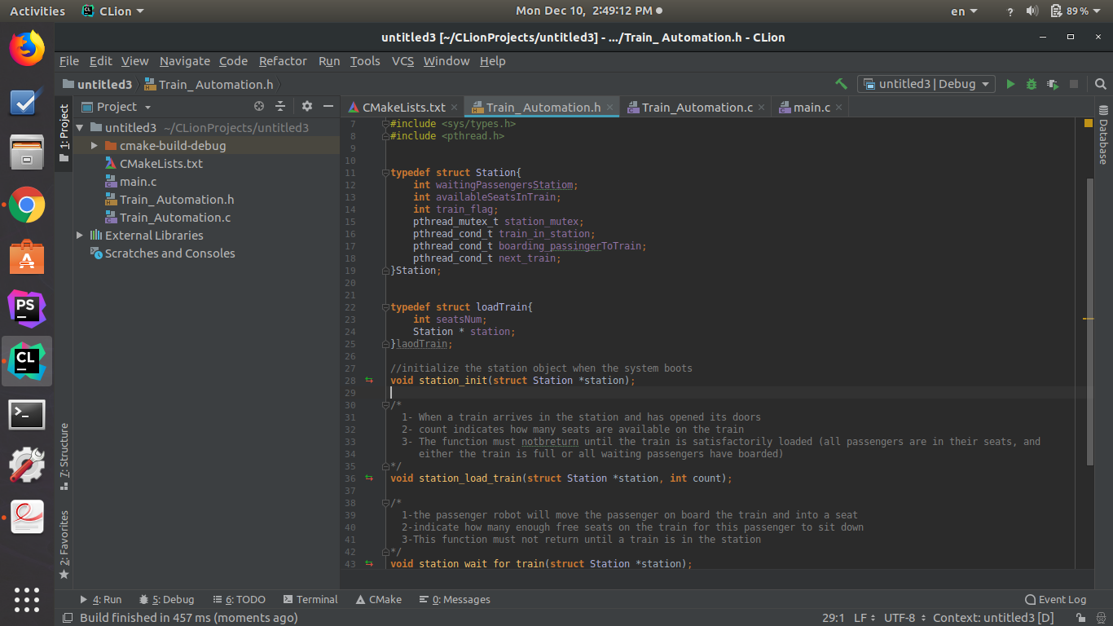
Function used :

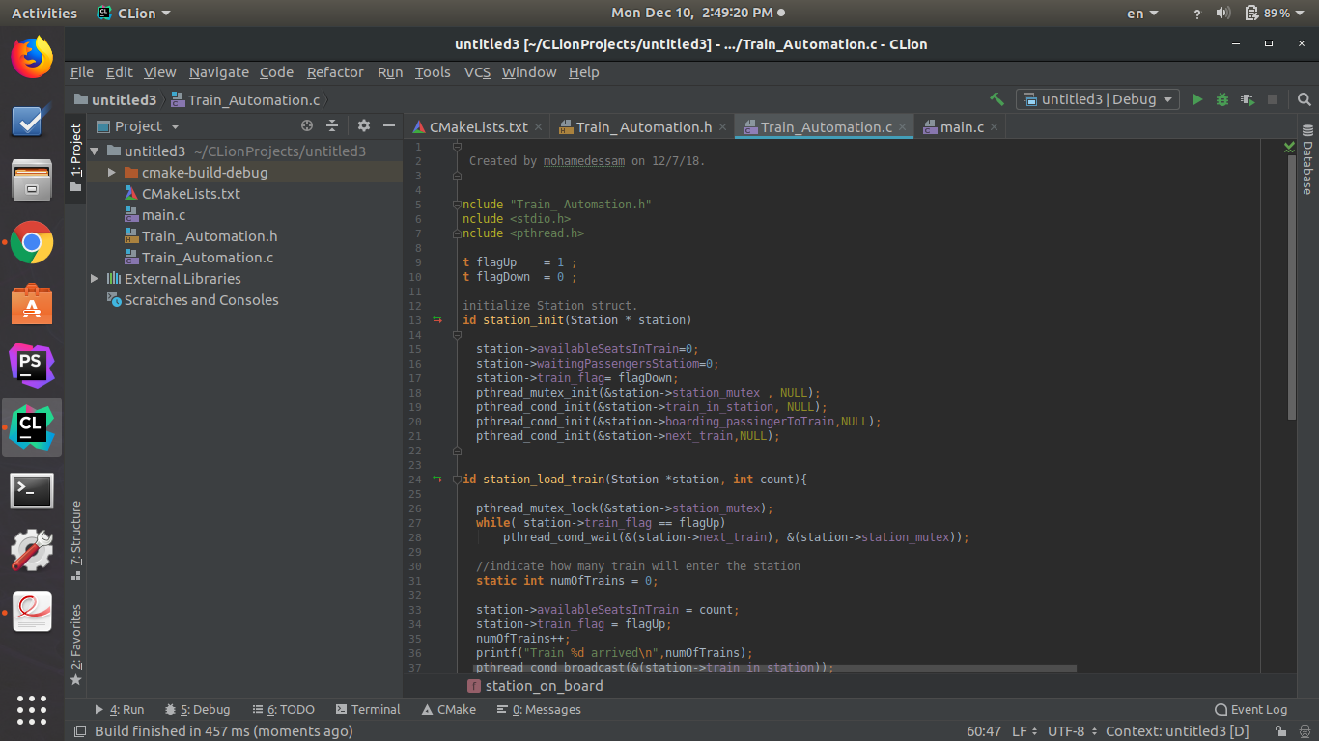
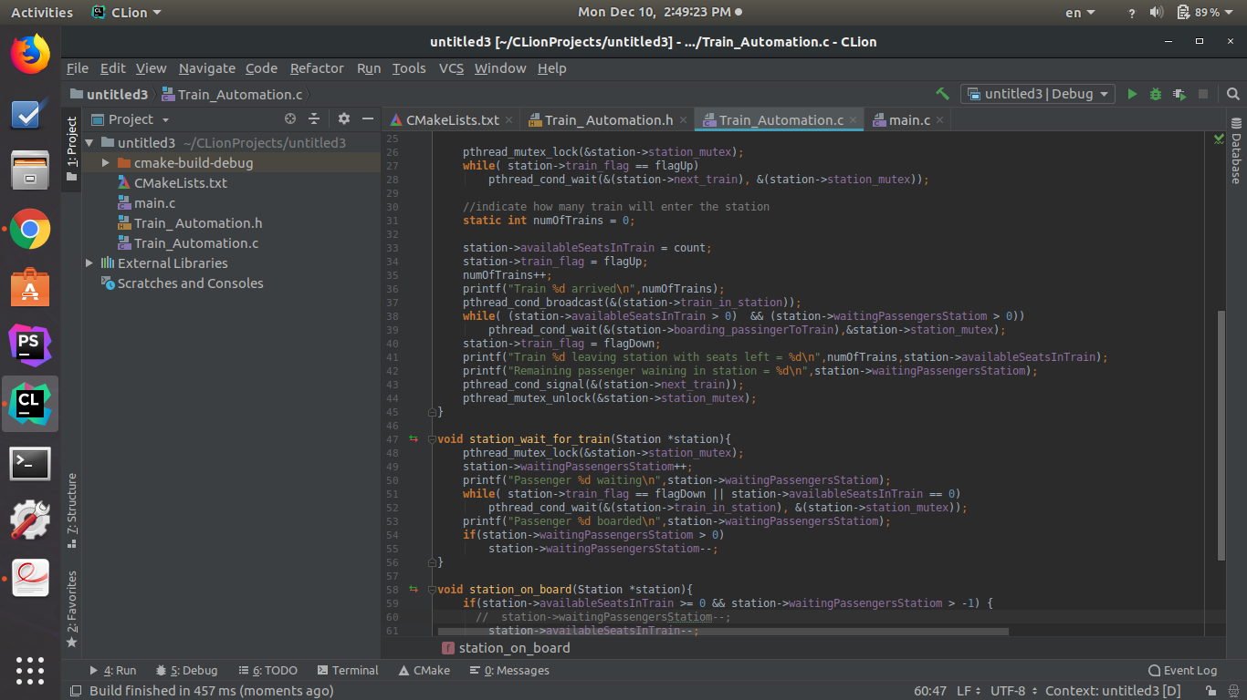

Main to test program :

